**Solutions**

1. For each of the following pairs of enterprise rule identify two entity types and one relationship type. State the degree of the relationship in each case.

a) A department employs many persons. A person is employed by, at most, one department.

Entity = Person and Department

Relationship type = One to One

Degree of the Relationship = 2 (binary)

b) A manager manages, at most, one department. A department is managed by, at most one manager.

Entity = Manager and Department

Relationship type = One to One

Degree of the Relationship = 2 (binary)

c) An author may write many books. A book may be written by many authors.

Entity = Books and Author

Relationship type = Many to Many

Degree of the Relationship = 2 (binary)

d) A team consists of many players. A player plays for only one team.

Entity = Team and Players

Relationship type = One to Many

Degree of the Relationship = 2 (binary)

e) A lecturer teaches, at most, one course. A course is taught by exactly one lecturer.

Entity = Lecturer and Course

Relationship type = One to One

Degree of the Relationship = 2 (binary)

f) A supervisor supervises a supervisee.

Entity = Supervisor and Supervisee

Relationship type = One to Many

Degree of the Relationship = 2 (binary)

g) An employee can be awarded many prizes.

Entity = Employee and Prizes

Relationship type = One to Many

Degree of the Relationship = 2 (binary)

2. Create an E-R diagram for the following:

a) Each company operates four departments and each department belongs to one company.

b) Each department in part a) employs one or more employees, and each employee works for one department.

c) Each employee in part b) may or may not have one or more dependents, and each dependent belongs to one employee.

d) Each employee in part c) may or may not have an employment history.

e) Represent all the E-R diagrams in a), b) c) and d) as a single E-R diagram.

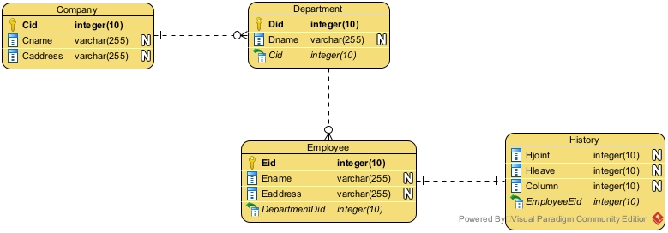

3.Create and E-R diagram for the following:

a) In an organisation it is required to store data on two types of vehicle: cars and trucks. All vehicles have the following attributes: vehicleId, make, model. Cars have one additional attribute, noOfSeats. Trucks have two additional attributes: class and payload.

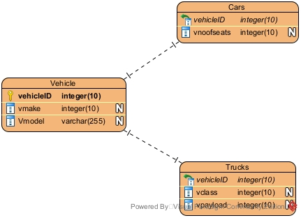

b) A researcher is investigating various family records in order to generate family trees by considering the ancestry of the people of a country. From the records it has been established that every person has many ancestors and that a person may be the ancestor of many persons.

